The site I will be working on is <https://furtadosschoolofmusic.com/>

This website is made by the music school of NMIMS and The Berkelee School of Music.

Category of the Website:- Music School

Name of the website:- Furtados School of Music

URL of the website:- <https://furtadosschoolofmusic.com/>

Coming to the good features of the website :-

1. The website has a proper brand logo in the title.
2. There is a proper video in the navbar jumbotron of the website.
3. There is hardly any repetition of words in the HTML Document.
4. The cards used in the carousel is wonderful.

Bad Features/ Areas where optimization is needed are:-

1. The website does not have a proper heading, with a proper font size and color contrast, this needs to be solved with utmost urgency.
2. The second div of the website has a guitar logo which covers most of the space in the division and the content gets hidden. This can be improved.
3. The div for the user count on the website can be kept live so that more and more people will know the fame of the website.
4. The links for the app downloads for apple store and play store can be incorporated in a navigation bar of the website so as to increase the downloads.
5. The navigation bar has a toggle dropdown button. Not everyone will use it. So links to different important pages should be incorporated in the navigation bar of the website.
6. The links inside the dropdown button can be well organized.
7. There are very few backlinks to the website which may result in hindrance to the rank of the website.

Remedies:-

**SEO ISSUE**: Poorly optimized meta data, descriptions and tags and NAP.

a. SEO Affect: Low ranking SERP results

b. Recommendation: Implement well structured and optimized Meta Data: Meta Descriptions, Title Tags, and NAP

c. SEO Result: Improved SERP position, increased search click-through-rate, and increased website traffic.

Analysis

· Identify and prioritize website business goals and objectives

· Gather information via SEO audit of the website and the website’s link profile.

· Analyze the SEO website audit, and link profile audit.

Strategies

· Create a list of items to be fixed, updated and/or changed on the website and link profile.

· Design strategy for creating new and updating content.

· Design strategy for adding new links to the website.

· Design a strategy for new keywords and meta data.

· Propose Appropriate solution.

Actions

· Implement the agreed upon strategies.

· Ongoing review, test and monitor progress for continual improvement.

**Question “can you guarantee that I will get into the top results in Google?”**

No two situations are alike. Even if two different websites are direct competitors, each has its own unique circumstances and factors affecting it. In addition, nobody has a crystal ball to predict what the market will or will not do, or demand. As such, we cannot guarantee certain results, but with sound logic, research, and testing following fundamental processes, we can anticipate a high probability of success. Our references will help to validate this, too.

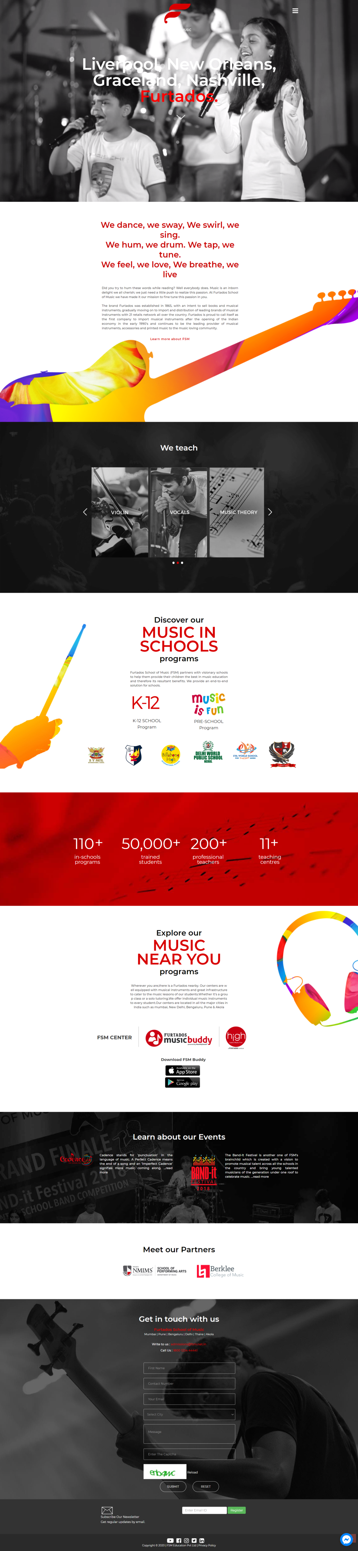Some backlinks can be added to the website as well:-

1. Firstly, the improvement in the about and Blogs page can be redesigned.
2. The link to the local business forum can be added as well.
3. The Harvard and London School of Music can be included.